**Project Report**

**on**

**Quiz App**

By

Ganesh Londhe, Vaibhav Jagtap

Indira College of Commerce and Science, Pune

M.Sc.(Comp. Sci.)-II

**Project Certificate**

**(should be taken from project/industry guide)**

**TABLE OF CONTENTS**

**CHAPTER 1: INTRODUCTION**

1.1 Existing System and Need for System

1.2 Scope of Work

1.3 Operating Environment – Hardware and Software

**CHAPTER 2: PROPOSED SYSTEM**

2.1 Proposed System

2.2 Objectives of System

**CHAPTER 3: ANALYSIS & DESIGN**

3.1 Data Flow Diagram (DFD)

3.2 Functional Decomposition Diagram (FDD)

3.3 UML Diagrams

3.3.1 Class Diagram

3.3.2 Object Diagram

3.3.3 Use Case Diagram

3.3.4 Sequence Diagram

3.3.5 Collaboration Diagram

3.3.6 State Diagram

3.3.7 Activity Diagram

3.3.8 Component Diagram

3.3.9 Deployment Diagram

3.4 Entity Relationship Diagram (ERD)

3.5 Data Dictionary

3.6 Table Design

**CHAPTER 4: USER MANUAL**

4.1 Operations Manual / Menu Explanation

4.2 Menu Screens

4.3 Project code

**CHAPTER 5: Limitations and Enhancement**

5.1 Drawbacks and Limitations

5.2 Proposed Enhancements

5.3 Conclusions

5.4 Bibliography

**1: INTRODUCTION**

* 1. **Existing System and Need for System**

There exists an advanced system than we have created in this project. We have created a basic application to fulfill our need to learn android development during the course of three months.

* 1. **Scope of Work**

Scope of this project is limited to the students. UG, PG students and anyone who is learning to develop an android app like quiz or similar.

* 1. **Operating Environment – Hardware and Software**

Operating System: Android version 4(Kitkat) and above

**2: PROPOSED SYSTEM**

**2.1 Proposed System**

This is a very basic quiz android application written in java. The inspiration for this project came from the guest lecture conducted in the Indira college with I visit this seminar.

The main design of the application follows the examples given in the lecture.

**2.2 Objectives of System**

Our main aim is to understand the logic behind the quiz application and to understand the android development.

**CHAPTER 3: ANALYSIS & DESIGN**

**3.1 Data Flow Diagram (DFD)**

Register

User_details Login

Test User

Start Complete End See Result

**3.3 UML Diagrams**

**3.3.1 Class Diagram**

LoginActivity

-email: string

-password: string

- login()

- register()

Class diagram

Subject

-php: String

-c++: String

-html: String

-java: String

+select_subject()

Register

-name: string

-email: string

- password

+register()

+login()

Questionary

- questions: string

-answers: string

+selectAnswer()

+goToNextQuestion()

+Upload_to_server()

Result

- score: Numeric

+ newText()

+ exit()

3.3.2 Object Diagram

Object diagram

LoginActivity

-email: string

-password: string

Subject

-php: String

-c++: String

-html: String

-java: String

Register

-name: string

-email: string

- password

Result

- score: Numeric

Questionary

- questions: string

-answers: string

+Upload_to_server()

**3.3.3 Use Case Diagram**

Register

Login

Select Sub

Starts Test

Ends Test

Ends Test

**Use case diagram: quiz app**

**3.3.4 Sequence Diagram**

Login

User

Register

Select Sub

Start Test

End Test

Result

Login

Register

**3.3.6 State Diagram**

Idle

Login

Register

Select sub

Start Test

End Test

Check result

**3.3.7 Activity Diagram**

Login

Register

Select Subject

Start Test

Complete Test

End Test

Check Result

Exit

**3.3.8 Component Diagram**

Register.java Login.java

Subject.java

Questionary.java

Result.java

**3.5 Data Dictionary**

Data Dictionary

Database – userManager

Table Name – "User_name”

|  |  |  |  |
| --- | --- | --- | --- |
| Column Name | Data Type | Constraints | Description |
| user_id | String | Primary Key | User id |
| user_name | String |  | User name |
| User_email | String |  | User email_id |
| Password | String |  | Contains passwords |

**4: USER MANUAL**

**4.1 Operations Manual / Menu Explanation**

**4.2 Menu Screens**

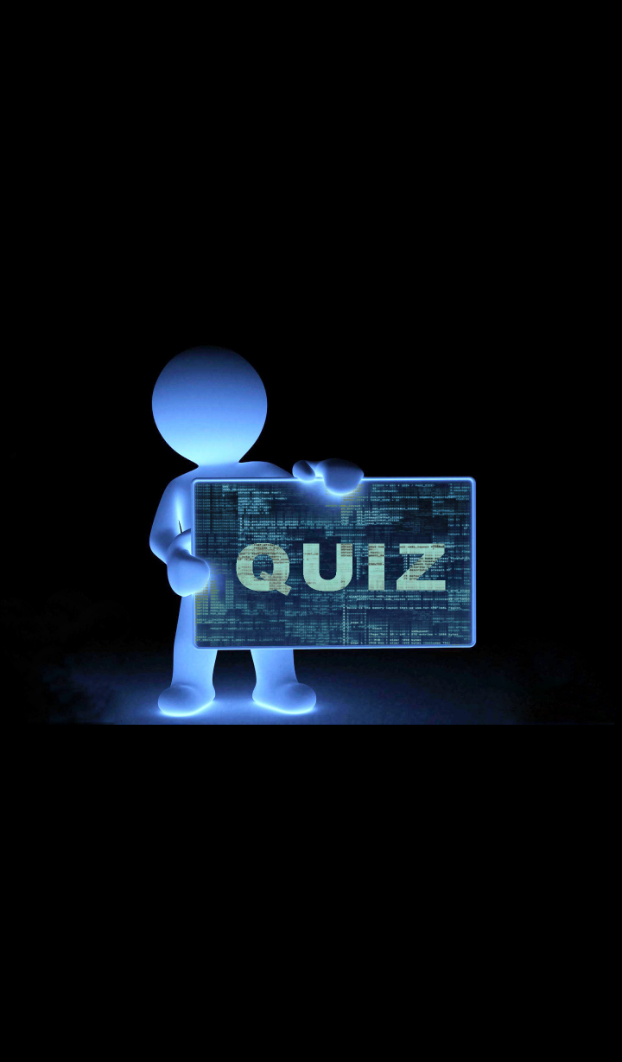

**Login Page**

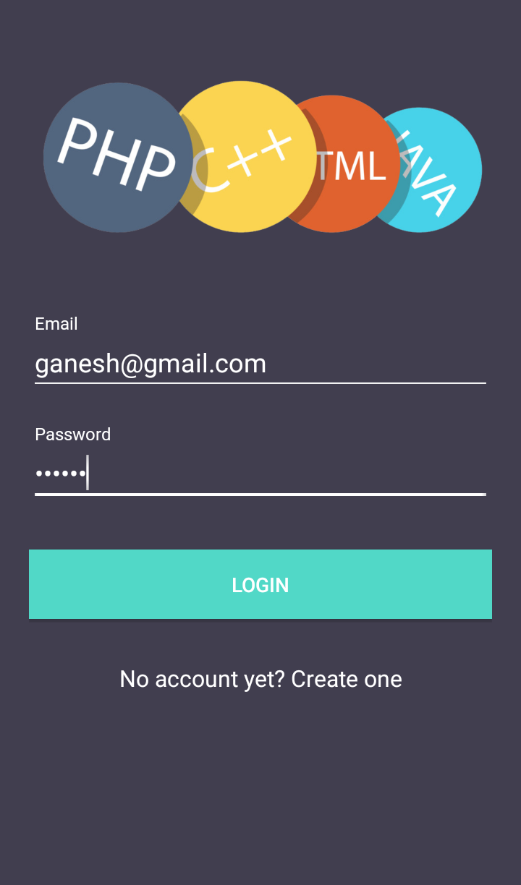

**Register Page**

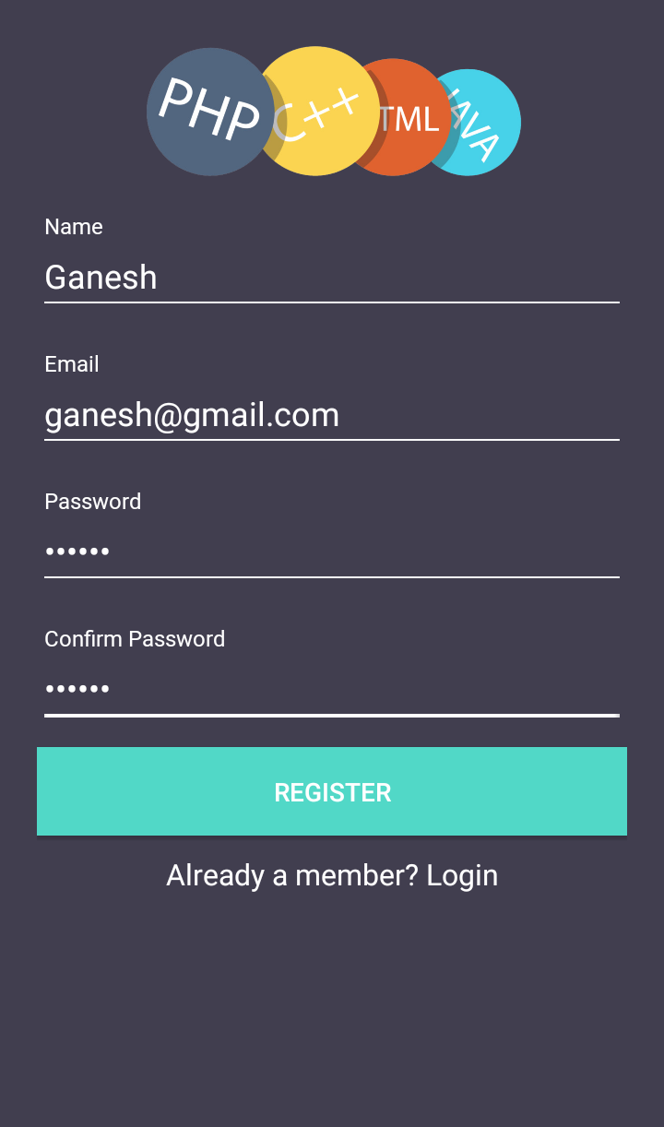

**Select Sub**

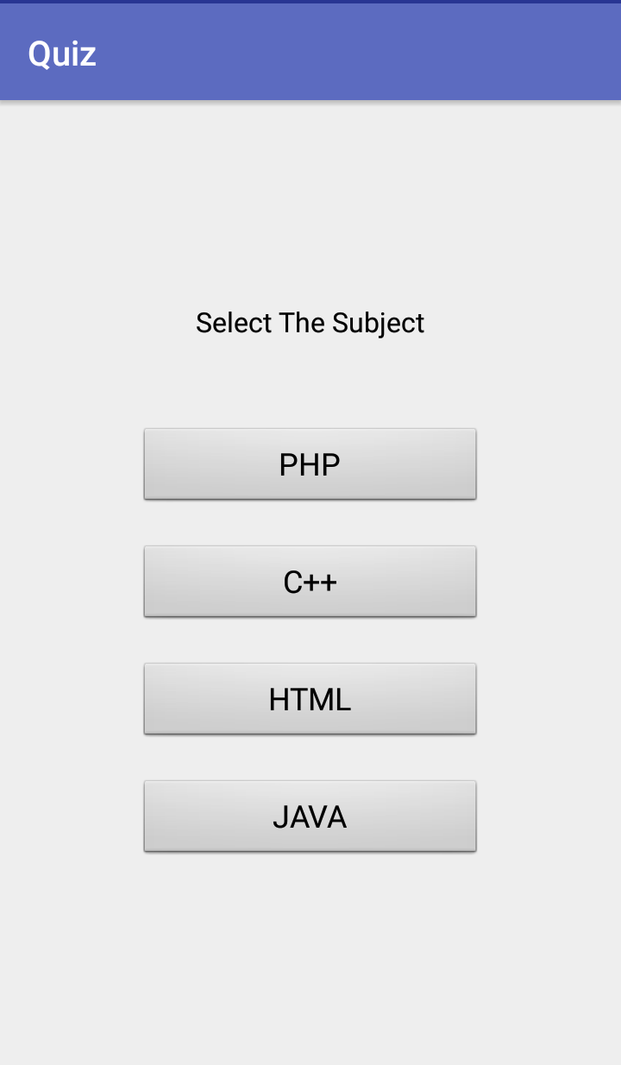

**Start Test**

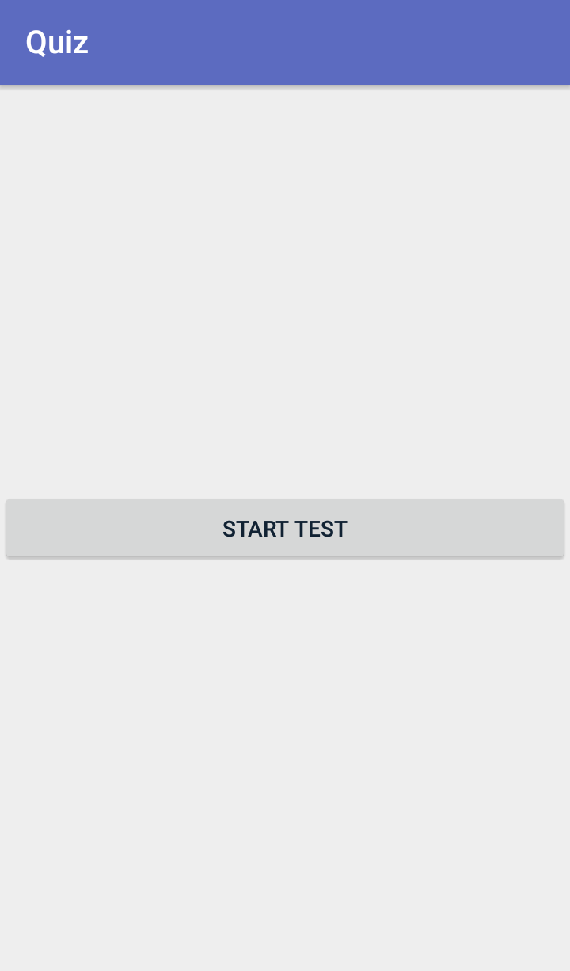

**During Test**

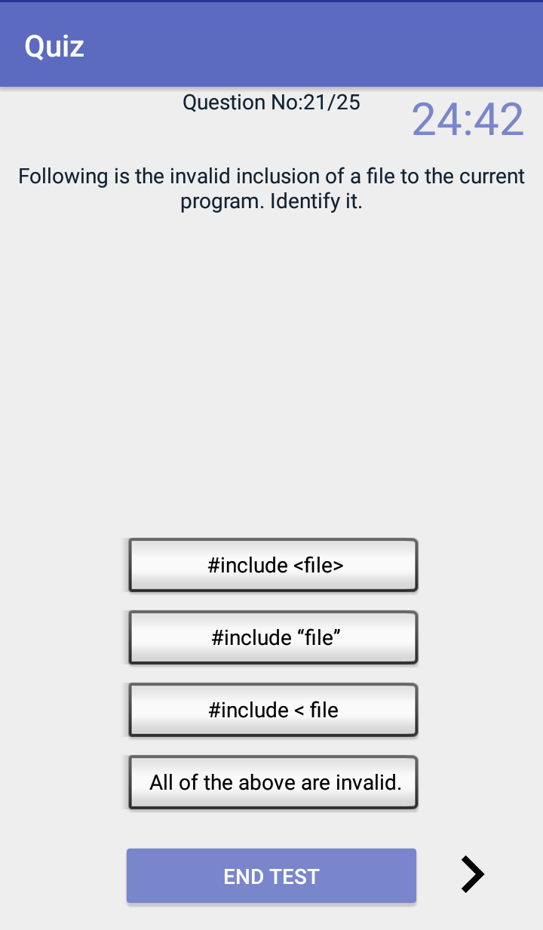

**Result Page**

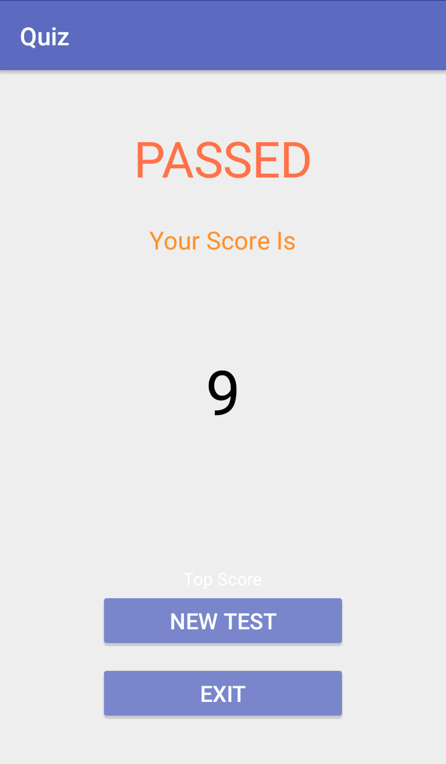

**Exit Confirmation Page**

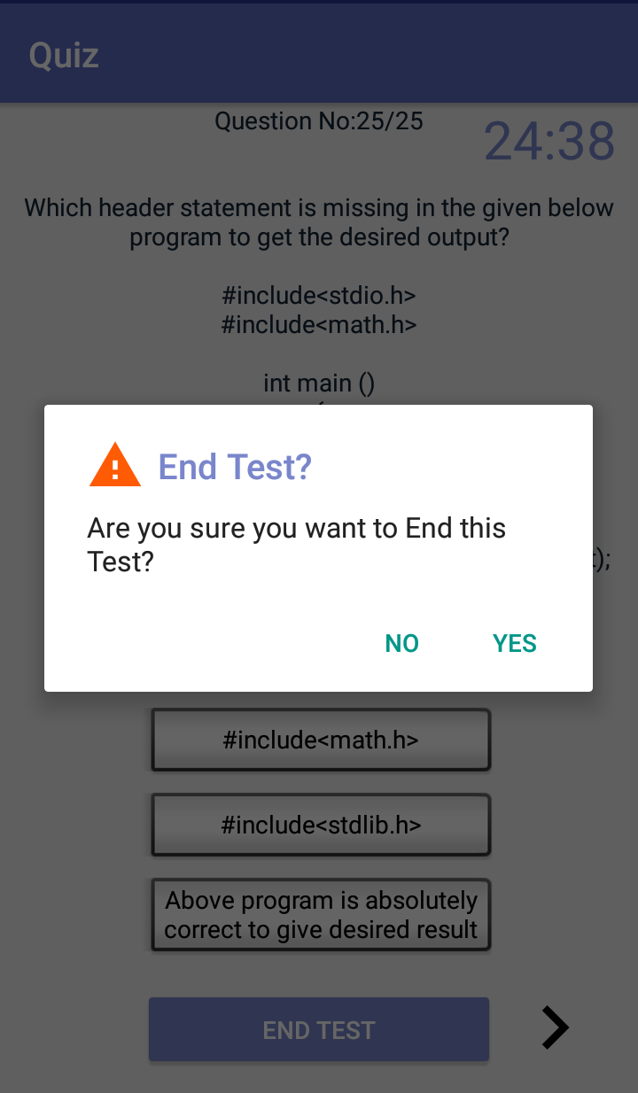

**4.3 Project code**

**5: Limitations and Enhancement**

**5.1 Drawbacks and Limitations**

* User can’t go back to the previous question
* User can’t go back to the skipped questions either
* Only valid user can make use of this software

Although the design and development are carried out in order to cover most of the functions of the system still there remains certain limitation in the system so far developed. This can be considered in further development of the project.

**5.2 Proposed Enhancements**

The project can be enhanced as per requirements of the client.

**5.3 Conclusions**

This project gave me an opportunity to understand the basic flow of an android application as per the expectation of the user and the challenges one faces during the course of developing and implementing the project successfully. We had the unique opportunity to work not just of a application but reporting a solution. An entire framework, where from a student to the top-level technician can use it to make their task easier and faster.

It gives us immense pleasure and satisfaction to do a project in a field, I have always been interested in and which allowed me to use my desire to learn new technology and use my technical skills in an excellent way to give a result which was required, which has gone beyond my own expectations.

5.4 Bibliography

During development of any project some good sources should be referred. During the development of our project we referred some useful books which good sources of knowledge are.

[www.wikipedia.com](http://www.wikipedia.com)

[www.youtube.com](http://www.youtube.com)

[www.developer.android.com](http://www.developer.android.com)